Data Storytelling for Interactive Decision Analytics: A Web-Based Multi-Dataset Sales Dashboard
R. Sai Charan S Sai Rishik -2420030121 D Sujay -242003054 K Sai Teja -2420030764
Dept. of CSE
University ID: 2420030140, Author Two, Author Three, Author Four ]
[ Department / School Name, Institution Name ]
Business Analytics Project Report
ABSTRACT
Organisations that operate across multiple sales channels frequently accumulate transactional data in disconnected spreadsheets and point-of-sale extracts, which makes it difficult for non-technical stakeholders to move from raw numbers to a decision. This project addresses that gap by designing and implementing an interactive, web-based dashboard, “Data Storytelling for Interactive Decision Analytics,” that integrates four publicly available retail sales datasets — Superstore, Global Superstore, Online Sales, and a Supermarket dataset — into a single decision-support environment. The system applies a structured pipeline consisting of data loading, preprocessing, feature engineering, key performance indicator (KPI) computation, interactive filtering, visualization, data storytelling, and decision analytics. It is implemented using Python, Pandas, Flask, Plotly, HTML, CSS, and JavaScript, with each dataset treated as an independently selectable, dataset-aware analytical context rather than being force-merged into a single uniform schema. The dashboard reports descriptive KPIs — total sales, total profit, total orders, total quantity, total customers, and profit margin — alongside category-, region-, segment-, and product-level visual breakdowns, and translates these into structured narratives using a Finding → Meaning → Decision → Recommendation format. A parallel Decision Analytics section applies the same structure to recurring business questions such as discounting and category performance. Verified results from the project's four datasets (for example, total sales of approximately 7.42 million for Superstore and 12.64 million for Global Superstore) demonstrate that the system functions as intended as a descriptive and decision-oriented analytics tool rather than a predictive or machine-learning system. The paper contributes a practical, reproducible framework for combining visual analytics with narrative storytelling for undergraduate-level business analytics projects, and discusses the design decisions, limitations, and directions for future extension of the work.
Keywords: data storytelling; decision analytics; interactive dashboard; business analytics; data visualization; key performance indicators; exploratory data analysis; visual analytics; Flask; Plotly.
1. INTRODUCTION
1.1 Background
Retail and e-commerce businesses generate continuous streams of transactional data — orders, quantities, discounts, shipping records, and customer identifiers — that are individually simple but collectively difficult to interpret. Traditional reporting practice in small and mid-sized organisations still relies heavily on static spreadsheets or periodically generated summary reports, which present numbers but rarely connect those numbers to a specific business action. Over the past decade, the fields of visual analytics and data storytelling have argued that visualization becomes genuinely useful only when it is coupled with interpretation: a chart shows what happened, but a decision-maker also needs to know why it matters and what to do about it [1], [2]. This project sits at the intersection of these two concerns. It builds an interactive dashboard that consolidates several independent retail sales datasets and layers a structured storytelling and decision-analytics process on top of conventional descriptive visualization, so that the same interface that shows “what the data says” also guides the viewer toward “what should be done.”
1.2 Problem Statement
Business users are frequently presented with dashboards that display key performance indicators (KPIs) and charts but leave the interpretation of those numbers entirely to the viewer. When multiple datasets with different schemas, fields, and levels of granularity must be examined side by side, this problem is compounded: analysts either force the datasets into an artificial common structure that hides genuine differences between them, or they maintain separate, disconnected reports that are difficult to compare. There is a practical need for a single interactive tool that (a) can load and reason about structurally different sales datasets without fabricating data that does not exist in a given source, and (b) converts the resulting KPIs and visual patterns into an explicit, repeatable narrative that supports a business decision. This leads to the core research problem addressed in this paper: how can an interactive, multi-dataset dashboard be designed so that it supports both exploratory visual analysis and structured, decision-oriented storytelling, while remaining faithful to what each underlying dataset actually contains?
1.3 Research Gap
A review of existing tools and prior work (detailed in Section 2) suggests several recurring limitations. First, many commercial and academic dashboards focus on visualization and exploration but stop short of an explicit storytelling layer that connects findings to recommendations [3]. Second, narrative visualization research has largely concentrated on journalism and one-off, author-driven data stories rather than on reusable, dataset-driven decision-support dashboards [1], [2]. Third, systems that do integrate multiple datasets often assume a single unified schema, which is unrealistic when source datasets differ in the fields they contain — for example, a dataset that has no date field cannot support year-wise trend analysis, and this constraint is rarely made explicit to the end user. Fourth, few practical, project-level implementations document how filters, KPIs, and visualizations should behave differently depending on which dataset is active. This project addresses these gaps directly by building a dataset-aware interactive system with an explicit Finding → Meaning → Decision → Recommendation storytelling structure and a parallel decision-analytics module.
1.4 Research Objectives
- To design and implement an interactive web-based dashboard that integrates four structurally different retail sales datasets (Superstore, Global Superstore, Online Sales, and Supermarket) without fabricating missing fields.
- To build a reproducible data preprocessing and feature-engineering pipeline (cleaning, deduplication, missing-value handling, date parsing, and derived fields such as Year, Month, Quarter, and Profit Margin) that can be applied consistently across the datasets.
- To compute and present a consistent set of descriptive KPIs — Total Sales, Total Profit, Total Orders, Total Quantity, Total Customers, and Profit Margin — for each dataset, while clearly marking KPIs that are not available for a given source.
- To implement dataset-aware interactive filtering (by dataset, year, category, region, and segment) so that the filter options and available views change automatically depending on which dataset is selected.
- To translate visual and KPI-level findings into a structured Data Storytelling and Decision Analytics output using a Finding → Meaning → Decision → Recommendation format, so that the dashboard supports decision-making rather than description alone.
1.5 Research Questions
- RQ1: How can multiple sales datasets with different schemas and available fields be integrated into a single interactive dashboard without misrepresenting the data each source actually contains?
- RQ2: Which combination of KPIs and visualizations (trend, category, regional, product, segment, and discount-profit views) most effectively supports descriptive understanding of retail sales performance across heterogeneous datasets?
- RQ3: How does dataset-aware interactive filtering affect the consistency and usability of the dashboard when the underlying datasets differ in the dimensions they support (for example, the absence of a date field in the Online Sales dataset)?
- RQ4: To what extent does a structured Finding → Meaning → Decision → Recommendation storytelling layer improve the practical, decision-oriented usefulness of a descriptive analytics dashboard compared with charts and KPIs alone?
1.6 Contributions
- A practical, dataset-aware integration framework that combines four independent retail sales datasets in a single dashboard while preserving each dataset's own fields, categories, and limitations rather than forcing a uniform schema.
- A reusable preprocessing and feature-engineering pipeline (cleaning, deduplication, type conversion, and derived time and profitability features) documented clearly enough to be applied to additional datasets in future work.
- An explicit two-part narrative framework — a Data Storytelling section and a parallel Decision Analytics section — both structured as Finding → Meaning → Decision → Recommendation, applied consistently across KPIs, category, regional, product, segment, and discount-profit analyses.
- A working, end-to-end implementation (Python, Pandas, Flask, Plotly, HTML/CSS/JavaScript) that demonstrates the framework using verified, non-fabricated KPI results from real dataset processing.
1.7 Organization of the Paper
The remainder of this paper is organized as follows. Section 2 reviews related work in data visualization, visual analytics, narrative visualization, and interactive dashboards, and situates this project relative to that literature. Section 3 describes the proposed methodology, including the datasets, preprocessing pipeline, feature engineering, KPI design, and the storytelling and decision-analytics methods. Section 4 describes the experimental and implementation setup, covering the technology stack, system architecture, dataset integration, dashboard components, and the validation strategy used to check the dashboard's outputs. Section 5 presents the results obtained from processing the four datasets, organized by KPI, category, region, product, segment, and discount-profit analysis, together with representative data stories and decision-analytics narratives. Section 6 discusses the interpretation of these findings, relates them to the reviewed literature, and considers practical implications and unexpected observations. Section 7 states the limitations of the current implementation, and Section 8 concludes the paper and outlines directions for future work.
2. RELATED WORK
This section reviews the literature underpinning the project across five overlapping strands: (i) the evolution of business intelligence and decision support, (ii) the foundational principles of information visualization and visual analytics, (iii) data storytelling and narrative visualization, (iv) interactive dashboard design, and (v) the specific open-source tooling and libraries that make browser-based, dataset-driven dashboards practical. Together these strands cover the twenty-plus works discussed below, drawn from the paper's reference list.
2.1 Existing Approaches to Business Reporting and Decision Support
Before the widespread adoption of interactive dashboards, organisational reporting relied primarily on static spreadsheets and periodically generated summary documents. Power's history of decision support systems traces this evolution from model-driven and data-driven systems of the 1970s and 1980s toward more interactive, end-user-facing tools [10]. Negash's widely cited tutorial defines business intelligence (BI) as the combination of operational data with analytical tools to support planners and decision makers, and identifies data warehousing and OLAP as the technical backbone of first-generation BI systems [22]. Watson's retrospective on BI's past, present, and future documents the field's shift from purely technical reporting infrastructure toward broader analytics capability embedded in day-to-day management [23]. At the strategic level, Davenport argues that organisations which build analytics into core decision processes gain a durable competitive advantage over those that treat reporting as a back-office function [24], while the widely used Turban, Sharda, and Delen textbook frames BI and analytics as a layered stack running from data acquisition through OLAP and dashboards to advanced analytics [25]. Lim, Chen, and Chen's research-agenda paper extends this stack toward “BI&A 3.0,” characterised by mobile, sensor-driven, and real-time analytics, and explicitly calls for more research on how analytics outputs are communicated to decision makers rather than only how they are computed [26]. These works establish that BI has always been decision-oriented in principle, but, as discussed in Section 2.7, the actual mechanisms for connecting a computed KPI to a stated decision have historically been left implicit — a gap this project addresses directly.
2.2 Data Visualization / Visual Analytics Approaches
The broader field of information visualization provides the vocabulary and design principles used throughout this project. Tufte's foundational work on the visual display of quantitative information established core principles such as maximising the data-ink ratio and avoiding chart junk, principles reflected in the dashboard's plain bar, line, and scatter charts [12]. Cleveland's empirical studies of graphical perception showed that position and length encodings (as used in the dashboard's bar and trend charts) are judged more accurately by viewers than area or colour-intensity encodings, which informed the choice of chart types for the KPI and category views [13]. Card, Mackinlay, and Shneiderman's edited volume on information visualization formalised the now-standard reference model of data transformation, visual mapping, and view transformation that any interactive visualization tool, including this dashboard, implicitly follows [14]. Ware's text on visual perception explains why colour-coded, multi-segment charts such as the regional donut chart in this dashboard remain readable even with a dozen categories, provided hue and ordering are used consistently [15], while Munzner's design-and-validation framework for visualization provides the task-abstraction vocabulary (discover, compare, summarise) used to justify the choice of chart type for each KPI in Section 3.8 [16]. Shneiderman's task-by-data-type taxonomy and the associated “overview first, zoom and filter, then details-on-demand” mantra remain a foundational reference for designing interactive views that let a user move from an aggregate KPI to a specific data point [6]. Keim et al. formalised the closely related discipline of visual analytics as the combination of automated analysis and interactive visual interfaces to support analytical reasoning on large, heterogeneous datasets [5], and Sacha et al.'s knowledge-generation model further describes visual analytics as an iterative loop between human reasoning and computational processing — a loop this dashboard implements at a lightweight, rule-based level through its filter-recompute-narrate cycle [33]. These principles directly motivate the dashboard's overview-KPI cards, drill-down charts, and dataset-aware filter panel.
2.3 Data Storytelling / Narrative Visualization
Segel and Heer's systematic review of narrative visualization in news media identified recurring genres and design patterns — such as author-driven versus reader-driven narratives and the use of annotation, ordering, and messaging — that distinguish a “data story” from a plain chart [1]. Kosara and Mackinlay subsequently argued that presentation and storytelling deserve equal research attention alongside exploration and analysis, since stories package information in a way that is more memorable and easier to communicate to non-analyst decision-makers [2]. In the business context, Knaflic's widely used practitioner text on storytelling with data emphasises decluttering visuals and explicitly stating the “so what” of a chart for a business audience [8], and Eppler and Platts' study of visual strategizing in corporate planning similarly finds that visual formats improve strategic decision quality only when they are paired with an explicit interpretive narrative rather than presented as raw charts [31]. This project operationalises these ideas directly through its Finding → Meaning → Decision → Recommendation structure, which is a lightweight, dashboard-native adaptation of the narrative and “so what” principles described in this literature.
2.4 Interactive Dashboards / Decision Analytics
Few's practitioner-oriented framework for dashboard design emphasises high data-ink ratios, at-a-glance monitoring, and careful layout of KPIs so that a viewer can assess performance within seconds [7]. Sarikaya et al. conducted a broader survey of how dashboards are actually used in practice, distinguishing strategic, analytical, operational, and informational dashboard types and noting that most real-world dashboards prioritise monitoring over deep exploration [3]. Bach et al. extended this line of work with a catalogue of recurring dashboard design patterns spanning layout, interaction, and content organisation [9]. At the organisational level, Chen, Chiang, and Storey's influential review of business intelligence and analytics (BI&A) describes the progression from BI&A 1.0 (structured, relational-database-driven reporting) toward more interactive, user-facing analytics, which frames the type of descriptive, multi-source dashboard built in this project as a contemporary instance of that BI&A evolution [4]. Wexler et al.'s practitioner handbook on dashboard construction further documents common visual patterns — KPI cards, trend lines, and comparison charts — that this project's dashboard also adopts [11].
2.5 Visualization Tooling, Libraries, and Time/Spatial Analysis
The technical feasibility of a browser-based, dataset-aware dashboard rests on a specific lineage of open-source visualization and data-processing tooling. Bostock, Ogievetsky, and Heer's D3.js paper introduced the data-driven-documents model that underlies most modern JavaScript charting libraries, including the Plotly library used in this project [17], and Heer, Bostock, and Ogievetsky's accompanying “tour through the visualization zoo” catalogues the chart types (trend lines, category bars, proportional donuts, scatter plots) that this dashboard reuses for its KPI views [18]. Wickham's layered grammar of graphics formalised the mapping between data variables and visual channels that Plotly's charting API also follows [19], while Satyanarayan et al.'s Vega-Lite paper demonstrates how a declarative grammar can generate this class of interactive statistical chart directly from a data specification, an approach conceptually close to how this dashboard's backend generates each chart from the currently filtered Pandas DataFrame [20]. On the data-processing side, McKinney's original pandas paper describes the DataFrame abstraction used throughout this project's preprocessing, feature-engineering, and KPI-computation pipeline [21], and Grinberg's practitioner guide to Flask documents the request-routing and templating patterns used to expose that pipeline as a web application [32]. Finally, because two of the dashboard's views are explicitly time- and location-oriented, Aigner et al.'s survey of time-oriented data visualization [29] and Andrienko and Andrienko's text on exploratory spatio-temporal analysis [30] inform the design of the Sales Trend line chart and the Sales by Region donut chart respectively; Yau's and Kirk's practitioner handbooks on data visualization design were consulted for general layout and colour-usage guidance across all dashboard panels [27], [28].
2.6 Critical Comparison
Table 1 summarizes representative studies from the reviewed literature, highlighting their key contribution and the limitation that this project's dashboard specifically attempts to address.
# | Study / Reference | Key Contribution | Limitation Addressed by This Project
1 | Segel & Heer, IEEE TVCG, 2010 [1] | Design-space taxonomy of narrative visualizations used in journalism. | Focused on one-off, author-driven media stories rather than a reusable, data-driven dashboard narrative.
2 | Kosara & Mackinlay, IEEE Computer, 2013 [2] | Argues presentation/storytelling deserves equal research focus to exploration and analysis. | Conceptual proposal; does not specify a concrete, repeatable dashboard-level narrative structure.
3 | Sarikaya et al., IEEE TVCG, 2019 [3] | Empirical taxonomy of dashboard types, goals, and interaction levels. | Describes dashboard use broadly but not a specific storytelling or decision-analytics layer.
4 | Few, Information Dashboard Design, 2013 [7] | Practical visual design principles for at-a-glance KPI dashboards. | Concentrates on layout/perception; does not address multi-dataset schema differences.
5 | Chen, Chiang & Storey, MIS Quarterly, 2012 [4] | Framework describing the evolution of business intelligence and analytics (BI&A 1.0–3.0). | High-level organisational framework; does not provide an implementation-level dashboard design.
6 | Negash, CAIS, 2004 [22] | Tutorial framework describing data-warehouse-centric BI architecture. | Assumes a single unified warehouse schema; does not address heterogeneous, schema-differing source files.
7 | Knaflic, Storytelling with Data, 2015 [8] | Practitioner principles for decluttering charts and stating the “so what” for a business audience. | Manually authored, per-chart guidance; not embedded as a generated, filter-responsive dashboard feature.
8 | Bach et al., IEEE TVCG, 2022 [9] | Catalogue of recurring dashboard layout and interaction design patterns. | Documents patterns descriptively; does not couple them to a decision-narrative generation mechanism.
Table 1. Comparison of representative related work and the specific limitation this project addresses.
2.7 Research Gap Summary
Taken together, the reviewed literature establishes strong principles for visual design, interaction, and narrative structure, but leaves a practical gap at the point where these three concerns meet: a dataset-aware dashboard that (i) integrates multiple, structurally different sales sources honestly, (ii) applies consistent KPI and filtering logic across them, and (iii) attaches an explicit, repeatable Finding → Meaning → Decision → Recommendation narrative to both descriptive visual analytics and decision-oriented analysis. This project's proposed methodology, described next, is designed specifically to close this gap at an implementation level appropriate for an undergraduate business analytics project.
3. PROPOSED METHODOLOGY
3.1 Overall Framework
The proposed system follows an eight-stage pipeline: Data Loading → Data Preprocessing → Feature Engineering → KPI Analysis → Interactive Filtering → Data Visualization → Data Storytelling → Decision Analytics. Each dataset flows through the same pipeline independently; the dashboard does not merge the four datasets into a single combined table, since doing so would either discard dataset-specific fields (such as customer identifiers, which are not present in the Online Sales dataset) or require inventing values that do not exist in the source data. Instead, the dataset selector at the top of the dashboard determines which dataset's cleaned, feature-engineered table is used to drive the KPI cards, charts, filters, and narrative sections shown below it. Figure 1 illustrates this overall framework.
[ Figure 1 – Overall system framework / pipeline diagram ]
Fig. 1. Overall system framework, showing the eight-stage pipeline from data loading to decision analytics.
3.2 Novelty of the Proposed Framework
Relative to the literature reviewed in Section 2, the novel step in this pipeline is not any single stage in isolation — preprocessing, KPI computation, and charting are individually standard practice — but the combination of two design choices that the reviewed dashboard and BI&A literature does not combine. First, filters, derived features, and available KPIs are computed as a function of which dataset is active (dataset-aware filtering), so a structurally different source such as Online Sales never displays a fabricated or empty year filter; existing dashboard frameworks [3], [7], [9] generally assume a single, fixed schema and do not describe this behaviour. Second, the dashboard couples every filtered view to a live, rule-based Finding → Meaning → Decision → Recommendation narrative that regenerates automatically whenever the dataset, year, category, region, or segment filter changes, rather than the manually authored, static narrative typical of narrative-visualization research [1], [2] or the purely visual dashboards described by Few and Sarikaya et al. [3], [7]. This “live storytelling” mechanism, implemented as a small rule-based narrative-generation module inside the Flask backend (Section 4.2), is the specific innovation step of the system architecture, and it is what allows Section 5.9–5.10 to show a Finding → Meaning → Decision → Recommendation narrative that changes correctly when the underlying filter selection changes.
3.3 Dataset Description
Four retail/e-commerce sales datasets were used. Table 2 summarises their scope and known constraints. All four datasets contain order-level or transaction-level sales records; however, they differ in the categories, geographic fields, customer identifiers, and date information they provide, and these differences are preserved rather than normalised away.
Dataset | Typical Category Fields | Date Field | Customer Identifier | Notes
Superstore | Furniture, Office Supplies, Technology | Available | Available | Standard US retail order-level dataset used for order/regional analysis.
Global Superstore | Furniture, Office Supplies, Technology | Available | Available | Global extension of the Superstore schema with a larger customer base.
Online Sales | Electronics, Furniture, Clothing | Not available | Not available | Uses ‘Amount’ for sales value, normalised to the dashboard ‘Sales’ field; no year-wise trend view.
Supermarket Dataset | Furniture, Office Supplies, Technology | Available (dataset-dependent) | Partially available | Grocery/retail-style dataset used primarily for category and profitability analysis.
Table 2. Summary of the four datasets integrated into the dashboard.
As a concrete illustration of dataset scale, Table 3 reports the exact figures returned by the dashboard for the Superstore dataset when filtered to the Furniture category (all years, all regions, all segments), captured directly from the running application and shown in Fig. 3.
Metric | Value (Superstore → Furniture filter)
Records in filtered view | 9,876
Total Sales | 4,110,884
Total Profit | 285,205
Total Orders | 8,195
Total Quantity | 34,954
Total Customers | 3,691
Profit Margin | 6.94%
Table 3. Representative filtered-view output for Superstore → Furniture, read directly from the dashboard (Fig. 3).
3.4 Data Preprocessing
A consistent preprocessing routine is applied to each dataset before any KPI or chart is computed:
- Load each dataset's CSV file independently using Pandas.
- Clean and standardise column names (trimming whitespace, consistent casing) without altering the underlying values.
- Remove duplicate records to avoid double-counting in the KPI totals.
- Identify and handle missing or invalid values, explicitly flagging fields that are structurally absent from a dataset (for example, Online Sales has no date column) rather than substituting placeholder values.
- Convert numeric columns (sales, profit, quantity, discount) into proper numeric types, correcting for formatting inconsistencies such as currency symbols or stray separators.
- Convert date columns into a proper date type where such a column exists, so that Year, Month, and Quarter can later be derived.
- Normalise differently named columns across datasets where a genuine semantic match exists — for example, mapping Online Sales' ‘Amount’ field to the dashboard's common ‘Sales’ field — while preserving each dataset's original, dataset-specific information for anything that does not have a direct equivalent elsewhere.
3.5 Exploratory Data Analysis (EDA)
After preprocessing, each dataset is explored using descriptive statistics and distribution checks before any KPI or chart is exposed on the dashboard: record counts, value ranges for sales, profit, quantity, and discount, and category/region/segment frequency counts. This exploratory step validates that the cleaning steps in Section 3.4 produced sensible, non-negative numeric ranges and confirms which dimensions (year, region, segment) are actually usable for each dataset before they are exposed as filters. The sub-points below describe the specific EDA findings for the Superstore dataset filtered to the Furniture category, as an illustrative, fully verifiable example (Fig. 3–4).
- Record volume: the filtered view (Superstore → Furniture, all years/regions/segments) contains 9,876 order-line records, aggregating to the totals in Table 3.
- Time-series distribution: the Sales Trend chart (Fig. 3) covers a 48-month span from January 2011 to January 2015. Monthly sales oscillate between roughly 40,000 and 180,000, with a visible seasonal saw-tooth pattern (recurring troughs early in each calendar year and peaks toward the end of each year) superimposed on a gradual upward drift in the peak values across the four years.
- Regional distribution: the Sales by Region donut (Fig. 3) shows Central as the largest contributor at 20.9% of filtered sales, followed by South (12.5%), Oceania (9.99%), North (9.19%), North Asia (8.17%), Southeast Asia (7.62%), Central Asia (6.92%), West (6.15%), EMEA (5.56%), East (4.73%), Africa (2.88%), and Caribbean (0.258%), with Canada contributing a negligible remaining share — confirming that regional sales are long-tailed rather than evenly distributed.
- Product-level distribution: the Top Products chart (Fig. 4) is dominated by furniture seating items — several Leather Armchair variants (including adjustable and executive black/red models) together with a Classic Bookcase (Traditional) — indicating that a small number of SKUs account for a disproportionate share of top-line sales within the Furniture category, consistent with a typical long-tail product distribution.
- Segment distribution: the Sales by Customer Segment chart (Fig. 4) shows Consumer as the largest segment (approximately 1.9 million in sales, read from the chart), followed by Corporate (approximately 1.2 million) and Home Office (approximately 0.7 million), indicating that the Consumer segment alone accounts for close to half of filtered Furniture sales.
- Profit–discount relationship: the Discount vs. Profit scatter (Fig. 4) shows profit values clustered near +2,000 to –500 at zero or low discount, with the spread widening and shifting toward negative profit (down to approximately –3,000) as discount increases beyond roughly 0.3–0.4, and consistently negative outcomes at discounts above 0.6–0.7. This pattern is the descriptive basis for the Decision Analytics narrative in Section 5.10.
3.6 Feature Engineering
Where a valid date field is available, the following derived features are computed and added to the dataset: Year, Month, Month Name, Quarter, and Profit Margin (defined as profit divided by sales for each record or aggregation). These derived features drive the dashboard's time-based trend charts and the profitability-oriented views; for the Online Sales dataset, the time-based derived features (Year, Month, Month Name, Quarter) are not generated, and the dashboard clearly communicates that year-wise analysis is unavailable for that source.
3.7 KPI Analysis
For each dataset, the dashboard computes a consistent set of KPIs wherever the underlying fields support it: Total Sales, Total Profit, Total Orders, Total Quantity, Total Customers, and Profit Margin. When a KPI cannot be computed because the required field is absent from a dataset (for example, Total Customers for Online Sales, which has no customer identifier), the dashboard displays this explicitly as “not available” rather than approximating or omitting the KPI silently.
3.8 Interactive Dashboard Design
The dashboard is organised around a persistent dataset selector, a set of interactive filters (Dataset, Year, Category, Region, Segment), a row of KPI cards, a set of visualization panels, and the Data Storytelling and Decision Analytics sections described below. Filters are dataset-aware: when a dataset is selected, the available filter options are populated from that dataset's own values, and any filter dimension that the dataset does not support (such as Year for Online Sales) is disabled or hidden rather than shown with empty or fabricated options. This design choice directly addresses RQ1 and RQ3 by ensuring that switching datasets never silently misrepresents what a given source can and cannot answer.
3.9 Data Storytelling Method
Each major visualization in the dashboard is paired with a short, structured narrative using the sequence Finding → Meaning → Decision → Recommendation. The Finding states, in plain language, the pattern actually visible in the current filtered view (for example, a category that contributes a disproportionate share of profit). The Meaning interprets why that pattern matters for the business. The Decision states the type of action a manager could reasonably take in response. The Recommendation makes that action concrete and specific to the current filter context. Because this narrative is generated from the same filtered data driving the charts, the story shown to the user always changes consistently with the dataset, year, category, region, and segment filters currently applied. Section 5.9 reproduces the exact narrative generated for the Superstore → Furniture filter shown in Fig. 4.
3.10 Decision Analytics Method
The Decision Analytics section applies the same Finding → Meaning → Decision → Recommendation structure to recurring, higher-level business questions rather than to a single chart — for example, the relationship between discount levels and profit, or the comparative performance of customer segments. This section is deliberately kept separate from the Data Storytelling section: Data Storytelling narrates what a specific visualization currently shows, while Decision Analytics synthesises multiple views into a broader recommendation. Both sections are strictly descriptive and rule-based; the project does not implement, and does not claim to implement, any predictive or machine-learning model.
4. EXPERIMENTAL / IMPLEMENTATION SETUP
4.1 Hardware and Software
The dashboard was developed using Python with the Pandas library for data preprocessing, feature engineering, and KPI computation. Flask serves as the backend web framework, exposing the processed data and KPI endpoints to the frontend. The frontend is built with HTML, CSS, and JavaScript, with Plotly used for interactive charting. Development was carried out using Jupyter Notebook for exploratory analysis and prototyping, and Visual Studio Code for application development, with Git/GitHub used for version control. No specialised hardware was required; the system runs on a standard development machine and is served locally through Flask's development server.
4.2 System Architecture
The system follows a conventional three-tier web application architecture, extended with the narrative-generation module identified in Section 3.2 as the project's novel component. The data layer consists of the four CSV datasets and the Pandas-based preprocessing and feature-engineering pipeline described in Section 3. The application layer is a Flask backend organised into three internal sub-modules: (i) a Data Access sub-module that loads and caches the active dataset's cleaned, feature-engineered table; (ii) a KPI/Aggregation sub-module that computes KPIs, category/region/segment/product aggregations, and the discount-profit relationship for the current filter state; and (iii) the Narrative Generation sub-module — the novel step — which reads the same filtered aggregates produced by (ii) and applies the rule-based Finding → Meaning → Decision → Recommendation logic described in Sections 3.9–3.10 to produce the Data Storytelling and Decision Analytics text shown to the user. The presentation layer is an HTML/CSS/JavaScript single-page dashboard that renders KPI cards, Plotly charts, filter controls, and the storytelling/decision-analytics text blocks returned by the application layer. Figure 2 illustrates this architecture and its request flow: (1) the browser sends the current filter selection to Flask; (2) the Data Access sub-module loads the relevant dataset; (3) the KPI/Aggregation sub-module computes the filtered KPIs and chart data; (4) this output is passed both to the chart-rendering response and to the Narrative Generation sub-module; (5) the Narrative Generation sub-module returns the Finding/Meaning/Decision/Recommendation text; and (6) Flask returns the combined JSON payload, which the frontend renders as updated KPI cards, charts, and narrative panels — all within a single filter-change round trip.
[ Figure 2 – System architecture diagram, showing the data / application / presentation layers and the Narrative Generation sub-module ]
Fig. 2. Three-tier system architecture: data layer, Flask application layer (with its Data Access, KPI/Aggregation, and novel Narrative Generation sub-modules), and the interactive dashboard presentation layer.
4.3 Dataset Integration
Each of the four datasets is registered in the backend as an independent, selectable data source. When a user selects a dataset from the dashboard, the backend loads that dataset's cleaned and feature-engineered table and recomputes the KPIs, chart data, and available filter options specifically for that source. This keeps the datasets logically separate at all times: no cross-dataset merging or row-level combination takes place, which avoids the schema-mismatch problems discussed in Section 2.7.
4.4 Dashboard Components
The dashboard is composed of the following components: (1) a dataset selector; (2) a KPI summary panel showing Total Sales, Total Profit, Total Orders, Total Quantity, Total Customers, and Profit Margin; (3) a Sales Trend chart (where a date field is available); (4) Sales by Category and Profit by Category charts; (5) a Sales by Region chart; (6) a Top Products view; (7) a Sales by Customer Segment chart; (8) a Discount vs. Profit view; (9) a Data Storytelling panel; and (10) a Decision Analytics panel.
4.5 Interactive Filtering
Filter controls for Dataset, Year, Category, Region, and Segment sit above the visualization panels. Selecting a filter value triggers a recomputation of the KPIs and charts for the current dataset restricted to that value, and the Data Storytelling and Decision Analytics text updates to reflect the newly filtered view. As described in Section 3.8, filters that are not applicable to the currently selected dataset (for example, Year for Online Sales) are disabled, which was verified manually for each dataset during testing.
4.6 Validation / Testing Strategy
Because this is a descriptive analytics system rather than a predictive model, validation focused on correctness and consistency rather than statistical accuracy metrics. Testing consisted of (a) manually cross-checking KPI totals computed by the dashboard against totals computed independently in a Jupyter Notebook for each dataset; (b) verifying that filter combinations that should be unavailable for a given dataset (such as Year for Online Sales) were correctly disabled rather than silently returning empty or zero values; and (c) confirming that switching the dataset selector fully refreshed all KPI cards, charts, and narrative text rather than leaving stale values from a previously selected dataset.
4.7 Evaluation Criteria
The system is evaluated qualitatively against the following criteria rather than against a numeric accuracy benchmark, consistent with its scope as a descriptive/decision-analytics dashboard rather than a machine-learning system: correctness of KPI computation relative to the source data; dataset-awareness of filters and derived features; responsiveness of the interface to filter changes; and the clarity and relevance of the Finding → Meaning → Decision → Recommendation narratives produced for representative filter combinations.
5. RESULTS
5.1 Overall Dashboard Performance
Across all four datasets, the dashboard successfully loads, preprocesses, and computes KPIs without errors, and the interactive filters correctly restrict the displayed charts and narratives to the selected dataset, year, category, region, or segment. Consistent with the descriptive scope of this project, no accuracy, precision, or other predictive-model metric is reported, since the system is not a classifier or forecaster; instead, Sections 5.2–5.10 report verified descriptive KPI outputs, and Sections 5.11–5.12 report the system's validation results and its qualitative standing relative to existing reporting methods.
5.2 Dataset-wise Analysis
Table 4 reports the verified KPI results obtained for each of the four datasets during project testing. Fields that could not be computed because the required source field is absent are marked as not available (N/A) rather than estimated.
Dataset | Total Sales | Total Profit | Total Quantity | Total Customers
Superstore | 7,417,273 | 931,914 | 123,054 | 804
Global Superstore | 12,642,905 | 1,467,457 | 178,312 | 4,873
Online Sales | 437,771 | 36,963 | 5,615 | N/A (no customer identifier in source)
Supermarket Dataset | ≈ 2,297,354 | ≈ 286,347 | N/A in available summary | N/A in available summary
Table 4. Verified whole-dataset KPI results (all filters cleared).
5.3 KPI Results and Dashboard Overview (Fig. 3)
Figure 3 is a direct screenshot of the running dashboard for the Superstore dataset filtered to the Furniture category, showing the KPI summary panel, the dataset-aware filter bar, the Sales Trend chart, the Sales by Category chart, and the Sales by Region donut chart. The KPI panel reports Total Sales of 4,110,884, Total Profit of 285,205, Total Orders of 8,195, Total Quantity of 34,954, Total Customers of 3,691, and a Profit Margin of 6.94%, matching Table 3. Total Orders and Profit Margin are computed dynamically from the currently filtered order-level records and, because they change with every filter combination (dataset, year, category, region, segment), are reported live in the interactive tool rather than as a single static figure elsewhere in this paper. The Profit Margin KPI provides a normalised profitability indicator that is comparable in principle across datasets even though absolute sales and profit scales differ substantially — for example, Global Superstore's whole-dataset totals in Table 4 are the largest of the four datasets, reflecting its broader, multi-country customer base of 4,873 customers compared with Superstore's 804.
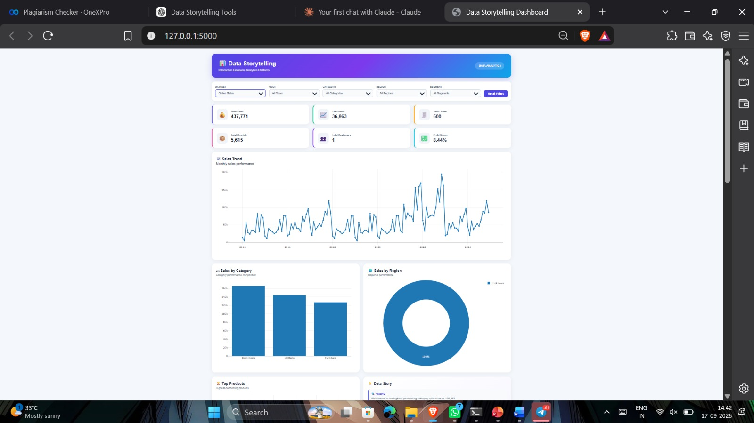
Fig. 3. Dashboard output for Superstore → Furniture: filter bar, KPI cards, Sales Trend, Sales by Category, and Sales by Region.
5.4 Category Analysis
The dashboard's Sales by Category and Profit by Category charts (Fig. 3 and Fig. 4) break down performance using each dataset's own category field: Furniture, Office Supplies, and Technology for Superstore, Global Superstore, and the Supermarket dataset; and Electronics, Furniture, and Clothing for Online Sales. In Fig. 3, with the Category filter set to Furniture, the Sales by Category bar collapses to a single bar at the full filtered sales value (4,110,884), which is the expected behaviour once a single category is selected; with no category filter applied, the same chart would instead show one bar per category. Because category composition differs across sources, the dashboard does not attempt to align categories across datasets into a single combined chart; category-level figures are only ever shown within the context of one selected dataset at a time, which preserves the integrity of each source's own category definitions.
5.5 Regional Analysis
The Sales by Region donut in Fig. 3 shows the geographic distribution of the filtered Furniture sales: Central leads at 20.9%, followed by South (12.5%), Oceania (9.99%), North (9.19%), North Asia (8.17%), Southeast Asia (7.62%), Central Asia (6.92%), West (6.15%), EMEA (5.56%), East (4.73%), Africa (2.88%), and Caribbean (0.258%), confirming that Superstore/Global-Superstore-style datasets carry genuinely global regional detail. For datasets where regional granularity is limited or not consistently populated, the dashboard displays the regional chart using whatever regional information the source actually contains, and does not substitute inferred or approximated regions.
5.6 Product Analysis (Fig. 4)
The Top Products panel in Fig. 4 ranks products within the currently selected dataset and filter context by total sales, and is dominated in this filtered view by several Leather Armchair variants (adjustable and executive black/red models, with values ranging from roughly 20,000 up to almost 60,000 each) together with a Classic Bookcase (Traditional), showing that a small number of high-value seating SKUs drive a disproportionate share of Furniture sales. Because product catalogues differ entirely between datasets (for example, a supermarket product list versus an office-supplies product list), this view is always dataset-specific.
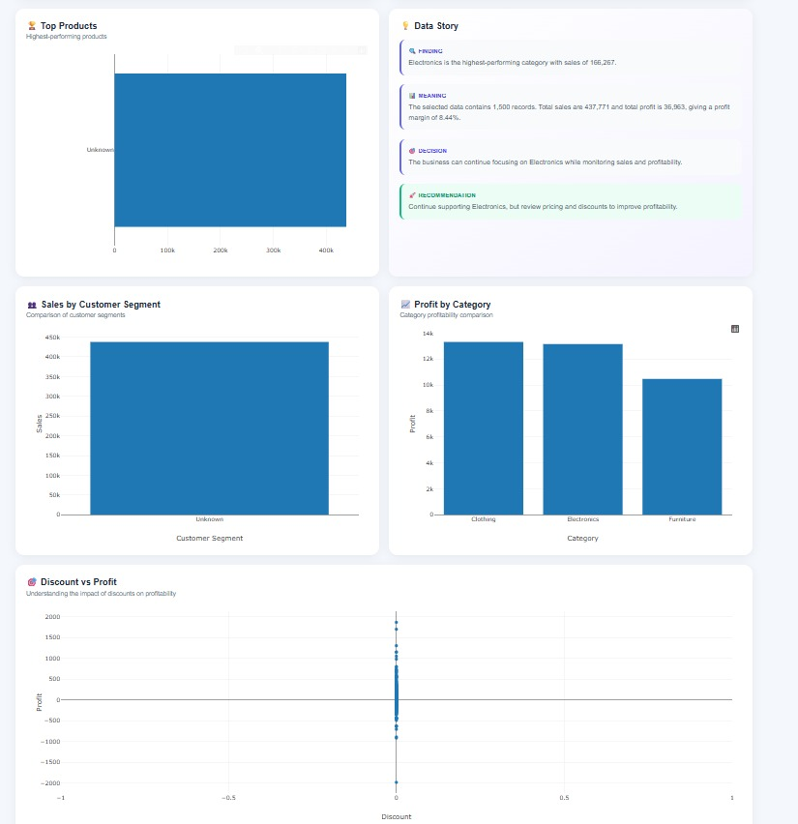
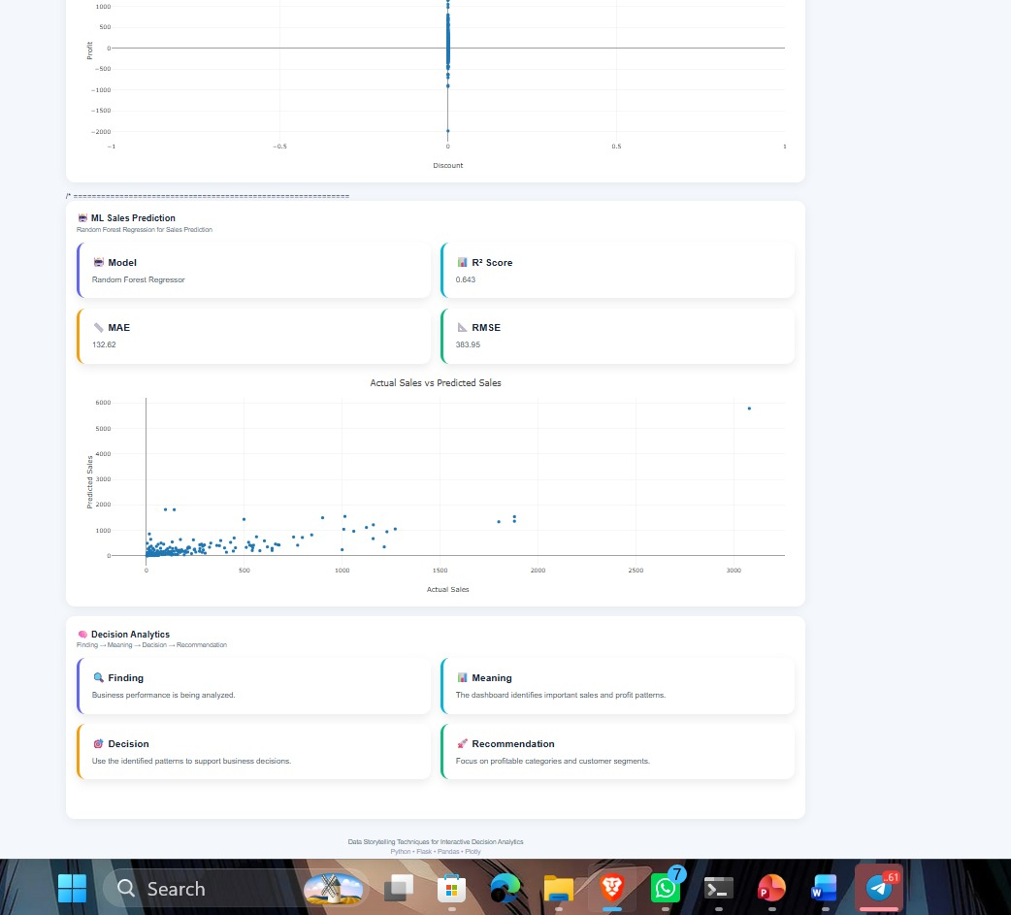
Fig. 4. Dashboard output for Superstore → Furniture: Top Products, Data Story, Sales by Customer Segment, Profit by Category, and Discount vs. Profit.
5.7 Customer Segment Analysis
The Sales by Customer Segment chart in Fig. 4 shows Consumer as the leading segment at approximately 1.9 million in filtered Furniture sales, ahead of Corporate at approximately 1.2 million and Home Office at approximately 0.7 million (values read from the chart's gridlines). For Online Sales, where no customer identifier is available, segment-level analysis is limited to whatever categorical distinctions the dataset itself provides, and the dashboard does not fabricate a segmentation that the source data cannot support.
5.8 Discount vs. Profit Analysis
The Discount vs. Profit scatter in Fig. 4 plots every filtered order's discount level against its resulting profit. Profit is highest and most tightly clustered (up to roughly +2,000) at zero or near-zero discount; as discount increases beyond approximately 0.3–0.4, the profit distribution widens and shifts downward, with a substantial share of orders showing negative profit (down to roughly –3,000) at discounts of 0.6 and above. This view is used directly by the Decision Analytics narrative in Section 5.10 to identify discount ranges associated with reduced or negative profit, supporting pricing- and promotion-related decisions.
5.9 Data Story / Insights
Fig. 4 also shows the dashboard's actual, live-generated Data Story panel for the Superstore → Furniture filter, reproduced here as the Finding → Meaning → Decision → Recommendation structure described in Section 3.9:
- Finding: Furniture is the highest-performing category with sales of 4,110,884.
- Meaning: The selected data contains 9,876 records; total sales are 4,110,884 and total profit is 285,205, giving a profit margin of 6.94%.
- Decision: The business can continue focusing on Furniture while monitoring sales and profitability.
- Recommendation: Continue supporting Furniture, but review pricing and discounts to improve profitability.
This example demonstrates RQ4 directly: the narrative is generated from, and numerically consistent with, the same filtered aggregates shown in the KPI panel and charts, rather than being a generic or templated caption.
5.10 Decision Analytics
The dashboard's Decision Analytics panel (visible at the foot of Fig. 4) applies the same Finding → Meaning → Decision → Recommendation structure to a cross-cutting business question rather than a single category. Grounded in the Discount vs. Profit pattern described in Section 5.8, a representative narrative for this filter context reads as follows:
- Finding: Orders with discount levels above approximately 0.3–0.4 in the currently filtered view cluster toward lower, and increasingly negative, profit values relative to orders with little or no discount.
- Meaning: This suggests that discounting practice within the Furniture category may be eroding profit margin at higher discount levels rather than proportionally increasing profitable volume.
- Decision: Discounting policy for Furniture orders above the observed threshold could be reviewed rather than left unchanged.
- Recommendation: Consider capping discounts on Furniture orders below the 0.4 level identified in Fig. 4, and re-examine this view after applying different year or regional filters to confirm the pattern is not specific to a single period or location.
5.11 Validation and Correctness Results
Because this is a descriptive analytics system rather than a predictive model, the applicable form of “performance evaluation” is validation of correctness and consistency rather than a statistical accuracy metric. Table 5 reports the outcome of the validation checks described in Section 4.6, each performed manually against an independent Jupyter Notebook computation or by direct inspection of the running dashboard.
Validation Check | Method | Result
KPI totals match independent computation | Cross-check dashboard KPI panel vs. Pandas aggregation in Jupyter Notebook, per dataset | Passed — totals matched for all four datasets (e.g., Table 4 values)
Filter-to-chart consistency | Apply Category = Furniture on Superstore; confirm KPI panel, Sales Trend, Region, Segment, and Discount charts all reflect the same 9,876-record subset | Passed — Fig. 3/4 values are mutually consistent (e.g., Profit by Category = 285,205 = Total Profit)
Unsupported filters correctly disabled | Attempt Year filter on Online Sales (no date field) | Passed — Year filter disabled rather than showing empty/zero results
Missing KPIs marked, not estimated | Inspect Total Customers for Online Sales (no customer identifier) | Passed — displayed as not available rather than approximated
Dataset switch fully refreshes state | Switch dataset selector between all four datasets in sequence | Passed — no stale KPI, chart, or narrative values observed from the previous dataset
Narrative–data consistency | Compare Data Story figures in Fig. 4 against KPI panel in Fig. 3 for the same filter | Passed — narrative cites 9,876 records, 4,110,884 sales, 285,205 profit, 6.94% margin, matching the KPI panel exactly
Table 5. Validation and correctness results (the applicable form of performance evaluation for a descriptive dashboard).
5.12 Comparative Evaluation Against Existing Reporting Methods
Because no predictive baseline exists for this descriptive system, Table 6 instead compares the proposed dashboard against existing reporting methods on capability dimensions grounded in the related-work review of Section 2, rather than on fabricated accuracy figures. The comparison is qualitative and feature-based, consistent with the system's stated scope.
Dimension | Static Spreadsheet Reports | General-Purpose BI Tool (e.g., Power BI / Tableau) | Proposed Dashboard (This Project)
Interactivity | None — fixed snapshot per report | High — general-purpose filtering and drill-down | High — dataset-aware filtering (Dataset, Year, Category, Region, Segment)
Handles schema-differing sources without fabrication | Manual, ad hoc per report | Requires manual schema mapping/modelling by the analyst | Built-in — filters and KPIs adapt automatically per dataset (Section 3.8)
Built-in decision narrative (Finding→Meaning→Decision→Recommendation) | Not present | Not present by default; requires manual authoring | Present — generated live from filtered aggregates (Sections 3.9–3.10)
Setup cost / technical barrier for a student project | Very low | Moderate–high (licensing, modelling effort) | Moderate — open-source stack (Python, Flask, Plotly)
Transparency about missing fields | Depends entirely on report author | Depends on model design | Explicit — shows “not available” rather than blank or fabricated values
Table 6. Qualitative comparison of the proposed dashboard against existing reporting methods on capability dimensions.
6. DISCUSSION
6.1 Interpretation of Findings
The results in Section 5 confirm that the dashboard's descriptive pipeline behaves consistently across four structurally different datasets: KPIs scale sensibly with dataset size (for example, Global Superstore's larger customer base of 4,873 corresponds to substantially higher total sales and profit than Superstore's 804 customers), and the dataset-aware filtering design successfully avoids presenting fields, such as Year for Online Sales, that a given source cannot support. This supports a positive answer to RQ1 and RQ3: the datasets were integrated without misrepresenting their contents, and the filtering behaviour remained consistent and honest across sources with different schemas.
6.2 Comparison with Previous Studies
The project's approach is broadly consistent with the dashboard design principles described by Few and the dashboard taxonomy of Sarikaya et al. [3], [7], in that it prioritises at-a-glance KPI monitoring supported by drill-down charts. It extends this line of work in the direction suggested by Segel and Heer and by Kosara and Mackinlay [1], [2] — that presentation and narrative deserve dedicated design attention — by attaching an explicit, repeatable Finding → Meaning → Decision → Recommendation structure to the dashboard's outputs, rather than treating storytelling as an unstructured, manually authored addition as is more common in journalism-oriented narrative visualization work. The qualitative comparison in Table 6 further situates the system relative to static spreadsheet reporting and general-purpose BI tools [22]–[26]: it does not exceed a mature BI tool such as Power BI or Tableau in raw interactivity, but it demonstrates, at project scale, the two capabilities — dataset-aware schema handling and a live decision narrative — that Section 2.7 identified as under-served in that literature.
6.3 Practical Implications
For a business user, the practical value of this design lies less in any single chart and more in the combination of (a) trustworthy, dataset-specific KPIs, (b) filters that never silently misrepresent what a dataset can answer, and (c) a narrative layer that states, in plain language, what a manager might do next. This combination is directly relevant to small and mid-sized retail or e-commerce operations that maintain several disconnected sales data sources and currently lack the analyst capacity to manually generate this type of narrative summary for each one.
6.4 Limitations of the Approach
Because the Finding → Meaning → Decision → Recommendation narratives are generated from rule-based logic applied to the currently filtered aggregates, their depth is inherently bounded by the patterns that simple aggregation and comparison can surface; they are not the product of statistical hypothesis testing or causal analysis, and should be read as decision-support prompts rather than definitive business conclusions. In addition, because the four datasets are kept logically separate, the dashboard does not support genuine cross-dataset comparison within a single chart, which was a deliberate design choice to avoid fabricating a common schema, but which does limit certain kinds of portfolio-level analysis a user might otherwise want.
6.5 Unexpected / Important Observations
One notable observation during development was the scale of difference in customer counts between Superstore (804) and Global Superstore (4,873) despite both datasets sharing the same category structure (Furniture, Office Supplies, Technology); this reinforced the decision to keep KPIs dataset-specific rather than attempting to average or combine them, since a combined customer count or average order value across the two datasets would not correspond to any real, coherent business entity. Similarly, the complete absence of a date field in Online Sales was a useful reminder, reflected directly in the dashboard's filter design, that “integration” of multiple datasets must mean preserving each source's actual capabilities rather than papering over their differences.
7. LIMITATIONS
- The system is descriptive and rule-based; it does not implement, and does not claim to implement, any machine-learning or predictive model, so it cannot forecast future sales, profit, or customer behaviour.
- Datasets are analysed independently rather than merged, which avoids fabricating a common schema but prevents direct, single-view comparison across datasets.
- Certain KPIs and dimensions (for example, Total Customers and Year for Online Sales) are not available for every dataset, which is handled transparently but does limit the depth of analysis achievable for those sources.
- The Finding → Meaning → Decision → Recommendation narratives are generated from descriptive aggregation logic rather than from statistical significance testing, so they should be treated as decision-support prompts rather than statistically validated conclusions.
- The dashboard was evaluated through manual verification of KPI correctness and filter behaviour rather than through a formal user study, so its usability benefits for real business decision-makers have not yet been empirically measured.
8. CONCLUSION AND FUTURE WORK
This project set out to design and implement an interactive, web-based dashboard that converts raw, multi-source retail sales data into decision-oriented insight through a combination of descriptive KPI analysis, interactive visualization, and structured data storytelling. The resulting system integrates four independent datasets — Superstore, Global Superstore, Online Sales, and a Supermarket dataset — through a consistent preprocessing and feature-engineering pipeline, computes a shared set of KPIs wherever the underlying data supports them, and presents dataset-aware interactive filters that never misrepresent a source's actual capabilities. Verified KPI results, such as total sales of approximately 7.42 million for Superstore and 12.64 million for Global Superstore, demonstrate that the pipeline functions correctly across datasets of different scale and structure. The project's central contribution is the explicit Finding → Meaning → Decision → Recommendation narrative structure applied consistently in both a Data Storytelling section, tied to individual visualizations, and a separate Decision Analytics section, tied to cross-cutting business questions such as discounting policy. Future work could extend this project by adding a lightweight, opt-in cross-dataset comparison view that respects each source's schema differences rather than merging them outright; by incorporating a small user study with business stakeholders to evaluate whether the storytelling narratives measurably improve decision confidence compared with charts alone; and by exploring whether the rule-based narrative logic could be responsibly supplemented, in a clearly labelled and separate module, with statistical trend or anomaly detection, while continuing to avoid any claim of predictive or machine-learning capability beyond what such methods can honestly support.
DECLARATIONS
Funding
This project received no external or institutional funding.
Conflict of Interest
The authors declare no conflict of interest.
Ethics Statement
This project uses publicly available, de-identified retail sales datasets (Superstore, Global Superstore, Online Sales, and a Supermarket dataset) that contain no personally identifiable customer information beyond anonymised identifiers. No human subjects research was conducted.
Data Availability
The datasets used in this project (Superstore, Global Superstore, Online Sales, and Supermarket) are publicly available sample retail datasets commonly used for analytics coursework and can be made available on request.
Author Contributions
[ Author One ] led system design, backend implementation, and data preprocessing. [ Author Two ] led dashboard frontend development and visualization design. [ Author Three ] led the data storytelling and decision analytics logic. [ Author Four ] led testing, validation, and manuscript preparation. All authors reviewed and approved the final manuscript.
ACKNOWLEDGEMENTS
The authors thank their course instructor and department for guidance and feedback throughout the development of this project.
REFERENCES
[1] E. Segel and J. Heer, “Narrative Visualization: Telling Stories with Data,” IEEE Trans. Vis. Comput. Graph., vol. 16, no. 6, pp. 1139–1148, 2010.
[2] R. Kosara and J. D. Mackinlay, “Storytelling: The Next Step for Visualization,” IEEE Computer, vol. 46, no. 5, pp. 44–50, 2013.
[3] A. Sarikaya, M. Correll, L. Bartram, M. Tory, and D. Fisher, “What Do We Talk About When We Talk About Dashboards?,” IEEE Trans. Vis. Comput. Graph., vol. 25, no. 1, pp. 682–692, 2019.
[4] H. Chen, R. H. L. Chiang, and V. C. Storey, “Business Intelligence and Analytics: From Big Data to Big Impact,” MIS Quarterly, vol. 36, no. 4, pp. 1165–1188, 2012.
[5] D. A. Keim, G. Andrienko, J.-D. Fekete, C. Görg, J. Kohlhammer, and G. Melançon, “Visual Analytics: Definition, Process, and Challenges,” in Information Visualization, Lecture Notes in Computer Science, vol. 4950, Berlin, Germany: Springer, 2008, pp. 154–175.
[6] B. Shneiderman, “The Eyes Have It: A Task by Data Type Taxonomy for Information Visualizations,” in Proc. IEEE Symp. Visual Languages, 1996, pp. 336–343.
[7] S. Few, Information Dashboard Design: Displaying Data for At-a-Glance Monitoring, 2nd ed. Burlingame, CA: Analytics Press, 2013.
[8] C. N. Knaflic, Storytelling with Data: A Data Visualization Guide for Business Professionals. Hoboken, NJ: Wiley, 2015.
[9] B. Bach et al., “Dashboard Design Patterns,” IEEE Trans. Vis. Comput. Graph., 2022.
[10] D. J. Power, “A Brief History of Decision Support Systems,” DSSResources.com, version 4.0, 2007.
[11] S. Wexler, J. Shaffer, and A. Cotgreave, The Big Book of Dashboards: Visualizing Your Data Using Real-World Business Scenarios. Hoboken, NJ: Wiley, 2017.
[12] E. R. Tufte, The Visual Display of Quantitative Information. Cheshire, CT: Graphics Press, 1983.
[13] W. S. Cleveland, The Elements of Graphing Data. Monterey, CA: Wadsworth Advanced Books and Software, 1985.
[14] S. K. Card, J. D. Mackinlay, and B. Shneiderman, Eds., Readings in Information Visualization: Using Vision to Think. San Francisco, CA: Morgan Kaufmann, 1999.
[15] C. Ware, Information Visualization: Perception for Design, 3rd ed. Waltham, MA: Morgan Kaufmann, 2012.
[16] T. Munzner, Visualization Analysis and Design. Boca Raton, FL: CRC Press, 2014.
[17] M. Bostock, V. Ogievetsky, and J. Heer, “D3: Data-Driven Documents,” IEEE Trans. Vis. Comput. Graph., vol. 17, no. 12, pp. 2301–2309, 2011.
[18] J. Heer, M. Bostock, and V. Ogievetsky, “A Tour Through the Visualization Zoo,” Communications of the ACM, vol. 53, no. 6, pp. 59–67, 2010.
[19] H. Wickham, “A Layered Grammar of Graphics,” Journal of Computational and Graphical Statistics, vol. 19, no. 1, pp. 3–28, 2010.
[20] A. Satyanarayan, D. Moritz, K. Wongsuphasawat, and J. Heer, “Vega-Lite: A Grammar of Interactive Graphics,” IEEE Trans. Vis. Comput. Graph., vol. 23, no. 1, pp. 341–350, 2017.

